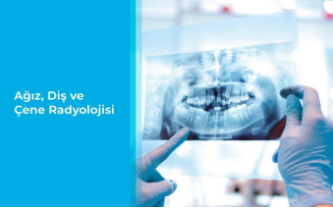**ASSOC. PROF. DR. KATİBE TUĞÇE TEMUR**

**CLINICAL SCIENCES- ORAL AND MAXILLOFACIAL RADIOLOGY**

**E-mail:** [tugcetemur@ohu.edu.tr](mailto:tugcetemur@ohu.edu.tr)

**BACHELOR’S DEGREE:** ISTANBUL UNIVERSITY-FACULTY OF DENTISTRY/DENTISTRY

**ASSOCIATE PROFESSOR:** NIGDE OMER HALISDEMIR UNIVERSITY/FACULTY OF DENTISTRY/DEPARTMENT OF CLINICAL SCIENCES/DEPARTMENT OF ORAL AND MAXILLOFACIAL RADIOLOGY

**ASSISTANT PROFESSOR:** KAHRAMANMARAS SUTCU IMAM UNIVERSITY/FACULTY OF DENTISTRY/DEPARTMENT OF CLINICAL SCIENCES/DEPARTMENT OF ORAL AND MAXILLOFACIAL RADIOLOGY

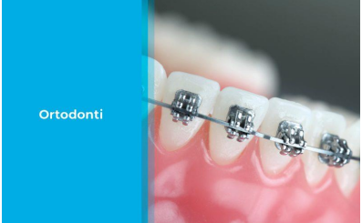**RESEARCH ASSISTANT:** CUKUROVA UNIVERSITY/FACULTY OF DENTISTRY/DEPARTMENT OF CLINICAL SCIENCES/DEPARTMENT OF ORAL AND MAXILLOFACIAL RADIOLOGY

**ASSOC. PROF. DR. KEVSER KURT DEMİRSOY**

**CLINICAL SCIENCES -ORTHODONTICS**

**E-mail:** [kevserkurtdemirsoy@ohu.edu.tr](mailto:kevserkurtdemirsoy@ohu.edu.tr)

**BACHELOR’S DEGREE:** HACETTEPE UNIVERSITY-FACULTY OF DENTISTRY/DENTISTRY

**ASSOCIATE DEGREE:** ANADOLU UNIVERSITY-OPEN EDUCATION FACULTY/DEPARTMENT OF THEOLOGY/THEOLOGY PROGRAM (ASSOCIATE DEGREE) (OPEN EDUCATION) /

**ASSOCIATE DEGREE:** ANADOLU UNIVERSITY-OPEN EDUCATION FACULTY/ DEPARTMENT OF LAW/JUSTICE PROGRAM (OPEN EDUCATION)

**DOKTORA:** ERCIYES UNIVERSITY- INSTITUTE OF HEALTH SCIENCES / DEPARTMENT OF ORTHODONTICS (DR)

**Thesis Title:** Comparison of different methods for evaluation and planning of orthognatic surgery treatment

**ASSOCIATE PROFESSOR:** NIGDE OMER HALISDEMIR UNIVERSITY/FACULTY OF DENTISTRY/DEPARTMENT OF CLINICAL SCIENCES/DEPARTMENT OF ORTHODONTICS

**ASSOCIATE PROFESSOR:** NEVSEHİR HACI BEKTAS VELI UNIVERSITY/FACULTY OF DENTISTRY/DEPARTMENT OF CLINICAL SCIENCES/DEPARTMENT OF ORTHODONTICS

**ASSISTANT PROFESSOR:** NEVSEHİR HACI BEKTAS VELI UNIVERSITY/FACULTY OF DENTISTRY/DEPARTMENT OF CLINICAL SCIENCES/DEPARTMENT OF ORTHODONTICS

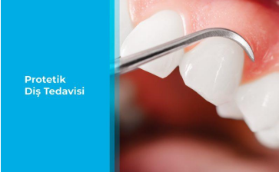

**ASST. PROF. DR. PELİN ATALAY SEÇKİNER**

**CLINICAL SCIENCES-** **PROSTHETIC DENTAL TREATMENT**

**E-mail:**  [pelinatalay@ohu.edu.tr](mailto:pelinatalay@ohu.edu.tr)

**BACHELOR’S DEGREE:** HACETTEPE UNIVERSITY-FACULTY OF DENTISTRY/DENTISTRY

**BACHELOR’S DEGREE:** ANADOLU UNIVERSITY-OPEN EDUCATION FACULTY/ DEPARTMENT OF SOCIOLOGY/SOCIOLOGY PROGRAM (OPEN EDUCATION)

**SPECIALTY IN DENTISTRY:** ANKARA UNIVERSITY-FACULTY OF DENTISTRY/DEPARTMENT OF CLINICAL SCIENCES/DEPARTMENT OF PROSTHETIC DENTAL TREATMENT/CROWN-BRIDGE DEPARTMENT

**Thesis Title:** Evaluation of zirconia implant systems in terms of failure TYPE and fracture strength

**ASSISTANT PROFESSOR:** NIGDE OMER HALISDEMIR UNIVERSITY/FACULTY OF DENTISTRY/DEPARTMENT OF CLINICAL SCIENCES/ DEPARTMENT OF PROSTHETIC DENTAL TREATMENT

**ASSISTANT PROFESSOR:** NIGDE OMER HALISDEMIR UNIVERSITY/FACULTY OF DENTISTRY/DEPARTMENT OF CLINICAL SCIENCES/ DEPARTMENT OF PROSTHETIC DENTAL TREATMENT

**RESEARCH ASSISTANT:** ANKARA UNIVERSITY/FACULTY OF DENTISTRY/DEPARTMENT OF CLINICAL SCIENCES/DEPARTMENT OF DEPARTMENT OF PROSTHETIC DENTAL TREATMENT

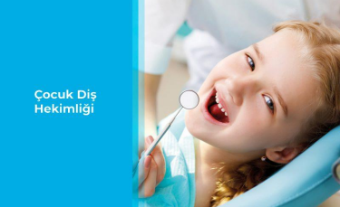

**ASST. PROF. DR. AYCAN DAL DÖNERTAŞ**

**CLINICAL SCIENCES-PEDIATRIC DENTISTRY**

**E-mail:** [adal@ohu.edu.tr](mailto:adal@ohu.edu.tr)

**BACHELOR’S DEGREE:** HACETTEPE UNIVERSITY-FACULTY OF DENTISTRY/DENTISTRY

**ASSOCIATE DEGREE:** ANADOLU UNIVERSITY-OPEN EDUCATION FACULTY/DEPARTMENT OF MANAGEMENT AND ORGANIZATION/MANAGEMENT OF HEALTH SCIENCES (OPEN EDUCATION) /

**SPECIALTY IN DENTISTRY:** GAZI UNIVERSITY FACULTY OF DENTISTRY/DEPARTMENT OF CLINICAL SCIENCES/DEPARTMENT OF PEDIATRIC DENTISTRY

**Thesis Title:** Evaluation of the knowledge and attitudes of pregnant women about infant oral health and their oral hygiene

**ASSISTANT PROFESSOR:** NIGDE OMER HALISDEMIR UNIVERSITY/FACULTY OF DENTISTRY/DEPARTMENT OF CLINICAL SCIENCES/DEPARTMENT OF PEDIATRIC DENTISTRY

GAZİ UNIVERSITY/FACULTY OF DENTISTRY/DEPARTMENT OF CLINICAL SCIENCES/DEPARTMENT OF PEDIATRIC DENTISTRY



**ASST. PROF. DR. ŞAFAK NECATİ DÖNERTAŞ**

**CLINICAL SCIENCES-** **PERIODONTOLOGY**

**E-mail:**  [safaknecatidonertas@ohu.edu.tr](mailto:safaknecatidonertas@ohu.edu.tr)

**BACHELOR’S DEGREE:** HACETTEPE UNIVERSITY-FACULTY OF DENTISTRY/DENTISTRY

**ASSOCIATE DEGREE:** ANADOLU UNIVERSITY OPEN EDUCATION FACULTY/ DEPARTMENT OF MANAGEMENT AND ORGANIZATION/MANAGEMENT OF HEALTH SCIENCES (OPEN EDUCATION)

**SPECIALTY IN DENTISTRY:** GAZI UNIVERSITY FACULTY OF DENTISTRY/DEPARTMENT OF CLINICAL SCIENCES/ DEPARTMENT OF PERIODONTOLOGY

**Thesis Title:** Determination of oral malodor awareness by applying a questionnaire and evaluation of the effect of different toothpastes on the oral malodor (Halitosis) by Halimeter

**ASSISTANT PROFESSOR:** NIGDE OMER HALISDEMIR UNIVERSITY/FACULTY OF DENTISTRY/DEPARTMENT OF CLINICAL SCIENCES/DEPARTMENT OF PERIODONTOLOGY

**RESEARCH ASSISTANT:** GAZI UNIVERSITY/FACULTY OF DENTISTRY/DEPARTMENT OF CLINICAL SCIENCES/ DEPARTMENT OF PERIODONTOLOGY



**ASST. PROF. DR. SELCEN ÖZCAN BULUT**

**CLINICAL SCIENCES- PERIODONTOLOGY**

**E-mail:**  [selcenozcanbulut@ohu.edu.tr](mailto:selcenozcanbulut@ohu.edu.tr)

**BACHELOR’S DEGREE:** HACETTEPE UNIVERSITY-FACULTY OF DENTISTRY/DENTISTRY

**SPECIALTY IN DENTISTRY:** HACETTEPE UNIVERSITY FACULTY OF DENTISTRY/DEPARTMENT OF CLINICAL SCIENCES/ DEPARTMENT OF PERIODONTOLOGY

**Thesis Title :** Retrospectively evaluation of the effectiveness of surgical approaches to patients with interdental papilla loss

**ASSISTANT PROFESSOR:** NIGDE OMER HALISDEMIR UNIVERSITY/FACULTY OF DENTISTRY/DEPARTMENT OF CLINICAL SCIENCES/ DEPARTMENT OF PERIODONTOLOGY

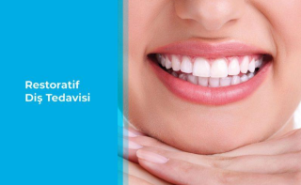

**ASST. PROF. DR. SERRA KUTLU KATIRCIOĞLU**

**CLINICAL SCIENCES-** **RESTORATIVE DENTAL TREATMENT**

**E-mail:**  [serrakutlukatircioglu@ohu.edu.tr](mailto:serrakutlukatircioglu@ohu.edu.tr)

**MASTER’S DEGREE:** HACETTEPE UNIVERSITY-FACULTY OF DENTISTRY

**SPECIALTY IN DENTISTRY:** SIVAS CUMHURIYET UNIVERSITY FACULTY OF DENTISTRY/DEPARTMENT OF CLINICAL SCIENCES/DEPARTMENT OF RESTORATIVE DENTAL TREATMENT

**Thesis Title:** Comparison of the microtensile bond strength of four different bulk-fill resin composites of class I cavities with dentin

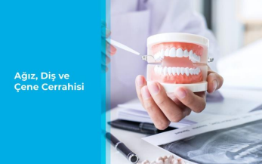**RESEARCH ASSISTANT:** CUMHURIYET UNIVERSITY/FACULTY OF DENTISTRY/DEPARTMENT OF CLINICAL SCIENCES/ DEPARTMENT OF RESTORATIVE DENTAL TREATMENT

**ASST. PROF. DR. NİDA GEÇKİL**

**CLINICAL SCIENCES- ORAL AND MAXILLOFACIAL RADIOLOGY**

**E-mail:**  [ngeckil@ohu.edu.tr](mailto:ngeckil@ohu.edu.tr)

**BACHELOR’S DEGREE:** ANKARA UNIVERSITY FACULTY OF DENTISTRY/DENTISTRY

**ASSOCIATE DEGREE:** ANADOLU UNIVERSITY OPEN EDUCATION FACULTY/DEPARTMENT OF MANAGEMENT AND ORGANIZATION/MANAGEMENT OF HEALTH SCIENCES (OPEN EDUCATION)

**SPECIALTY IN DENTISTRY:** CUKUROVA UNIVERSITY FACULTY OF DENTISTRY/DEPARTMENT OF CLINICAL SCIENCES/ DEPARTMENT OF ORAL AND MAXILLOFACIAL RADIOLOGY/ ORAL AND MAXILLOFACIAL RADIOLOGY

**THESIS TITLE:** Comparison of different fixation methods used in advancedadvancement and counterclockwise rotation of mandible



**ASST. PROF. DR. SERKAN YILMAZ**

**CLINICAL SCIENCES-** ORAL AND MAXILLOFACIAL RADIOLOGY

**E-mail:**  [serkanyilmaz@ohu.edu.tr](mailto:serkanyilmaz@ohu.edu.tr)

**BACHELOR’S DEGREE:** ANKARA UNIVERSITY FACULTY OF DENTISTRY/DENTISTRY

**MASTER’S DEGREE:** ERCIYES UNIVERSITY INSTITUYE OF HEALTH INSTITUTE/ BIOLOGY OF BIOINFORMATICS SYSTEMS (WITH THESIS)

**SPECIALTY IN DENTISTRY:** ERCİYES UNIVERSITY FACULTY OF DENTISTRY/DEPARTMENT OF CLINICAL SCIENCES/DEPARTMENT OF ORAL AND MAXILLOFACIAL RADIOLOGY

**Thesis Title** Comparative investigation of the performances of two different deep learning methods on classification of teeth using panoramic radiography

**RESEARCH ASSISTANT:** ERCIYES UNIVERSITY/FACULTY OF DENTISTRY/DEPARTMENT OF CLINICAL SCIENCES/DEPARTMENT OF ORAL AND MAXILLOFACIAL RADIOLOGY

**ASSISTANT PROFESSOR:** NIGDE OMER HALISDEMIR UNIVERSITY/FACULTY OF DENTISTRY/DEPARTMENT OF CLINICAL SCIENCES/DEPARTMENT OF ORAL AND MAXILLOFACIAL RADIOLOGY



**ASST. PROF. DR. ALPER KATIRCIOĞLU**

**CLINICAL SCIENCES-ORTHODONTICS**

**E-mail:**  [alperkatircioglu@ohu.edu.tr](mailto:alperkatircioglu@ohu.edu.tr)

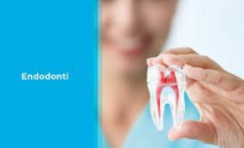

**ASST. PROF. DR. ZÜBEYDE GÖKÇE ÜRÜN**

**CLINICAL SCIENCES-ENDODONTICS**

**E-mail:**  [gurun@ohu.edu.tr](mailto:gurun@ohu.edu.tr)



**ASST. PROF. DR. BARIŞ ÜRÜN**

**CLINICAL SCIENCES- ENDODONTICS**

**E-mail:**  [barisurun@ohu.edu.tr](mailto:barisurun@ohu.edu.tr)

**ASST. PROF. DR. ÖZDEN MELİS DURMAZ YILMAZ**

**CLINICAL SCIENCES-PROTETİK DİŞ TEDAVİSİ**

**E-mail:**  [ozdenmelisdurmazyilmaz@ohu.edu.tr](mailto:ozdenmelisdurmazyilmaz@ohu.edu.tr)

**ASST. PROF. DR. ESMA KEZBAN AKDAŞ**

**CLINICAL SCIENCES-ORTHODONTICS**

**E-mail:**  [eakdas@ohu.edu.tr](mailto:eakdas@ohu.edu.tr)