  Nigde Omer Halisdemir University | SCIENTIFIC RESEARCH PROJECTS
 | Coordination unit
 | Editorial department

JOB DESCRIPTION |  | CODE |  | TOTAL TIME
Incoming Document Process |  |  |  | 1 hour 7 mins.


PEOPLE in CHARGE WORK FLOW
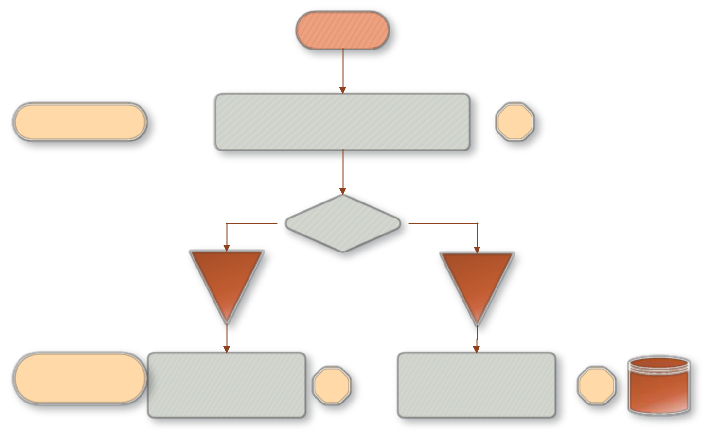

BEGINNING

Civil servant Checking the documents and its attachments 5 mins.

Arrival Type

By hand via the system

Civil servant |  |  |  | Referring the document from the EBYS to the unit
Civil servant | Scanning and saving the document through the EBYS system |  | 2 mins. |  |  | 2 dk.
 |  |  |  |  |  |  | EBYS
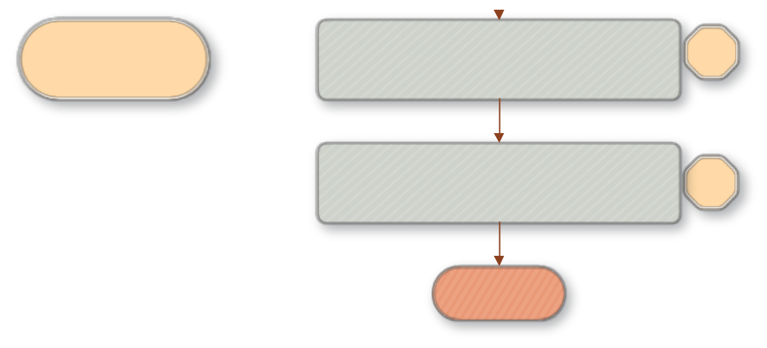

Civil servant, BAP Coordinator, general secretary, rector, vice rector | Initiating the document process. | 1
 | Initiating the document process. | hour


Memur | Filing the processed document | 2 mins..

END

