
Nigde Omer Halisdemir University
Scientific Research Projects
Coordination unit

Portable Registration and Control Unit

JOB DESCRIPTION |  | CODE |  | TOTAL TIME
Recording Process of Fixtures |  |  |  | 105 mins.
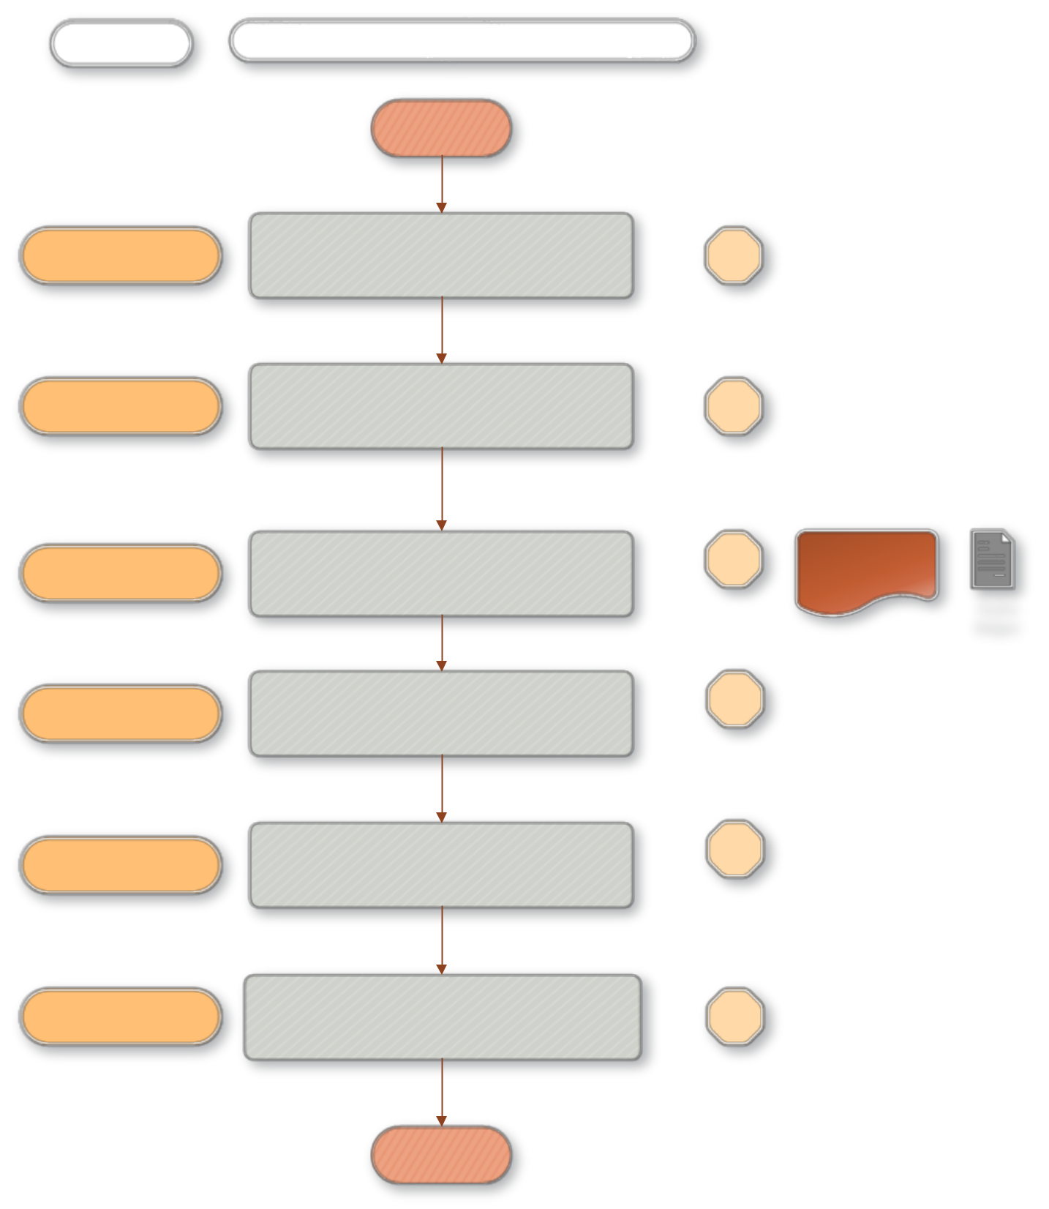

PEOPLE in CHARGE ^{WORK FLOW}

BEGINNING

In materials purchased through direct supply, the arrival and control of invoices
Civil servant

Determining the materials which have fixture properties through controlled bills
Civil servant

Civil servant
To prepare the delivery document of the materials and the report of the inspection acceptance commission, to sign it to the project principal investigator and its members
.

10 mins.

10 mins.

30 mins. | Inspection admission
30 mins. | Comission report

Delivery document

Civil servant

Recording the objects to be classified as fixtures according to the delivery and inspection documents

30 mins.

Civil servant
Transferring those fixtures whose registration is completed and sending them to the Strategy Development Department for payment.

Civil servant During the property checkout, sending the fixture to the related places in accordance with the request by the faculty or junior college .

15 dk

10 dk

END

