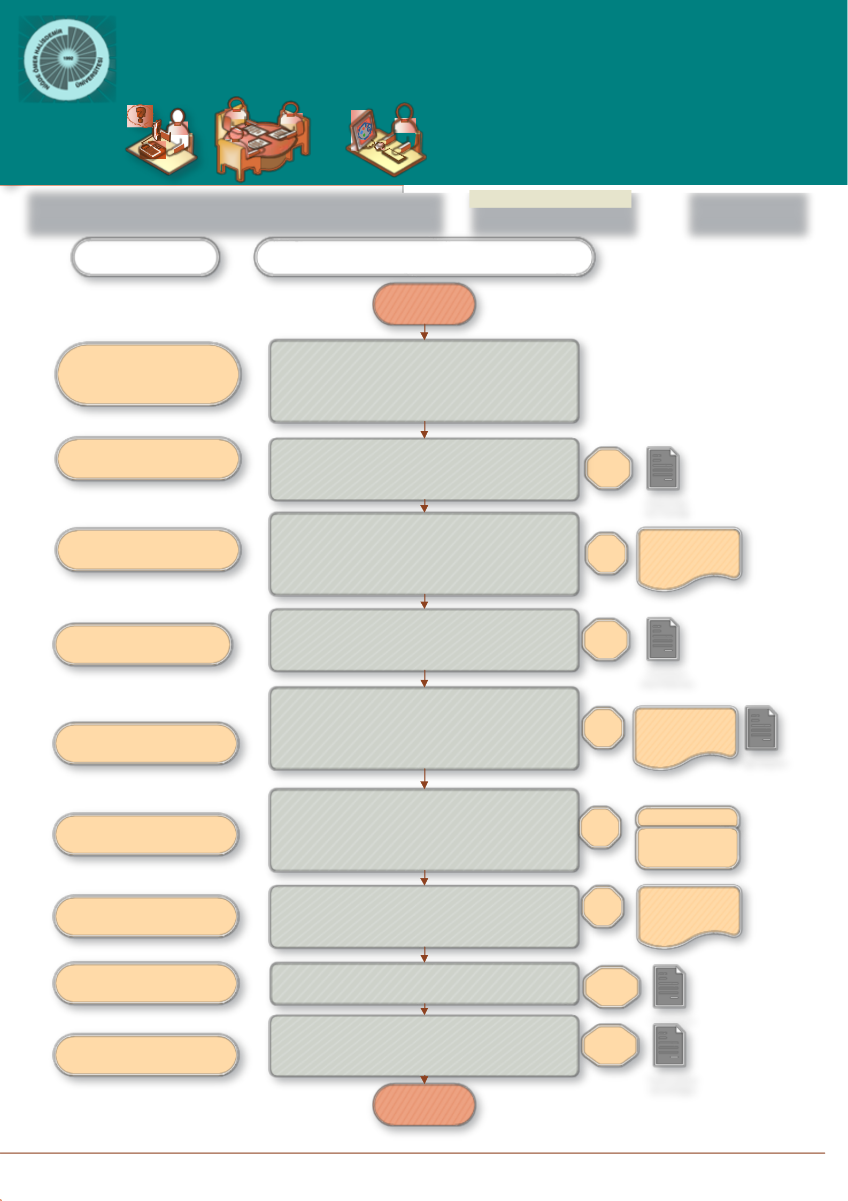
Nigde Omer Halisdemir UniversitY
Scientific research projects
Coordination unit
Purchasing unit

JOB DESCRIPTION |  |  | CODE |  | TOTAL TIME
Pre-Tender Transactions |  |  |  |  | 1 month 14 days
PEOPLE in CHARGE | WORK FLOW

BEGINNING

Project principle investigator,
civil servant, spending
authority, secretary, vice rector

Civil servant, implementation and spending authority

civil servant, implementation authority, secretary, vice rector

civil servant, spending authority
Pre-tender transactions

Receiving the request and technical specifications by the Project principle investigator, checking the appropriation by our unit, evaluating the request.

Approximate Cost Determination

Making Market Price Research by obtaining offers from companies to determine the approximate cost.

Receiving Tender Approval and Signing
Determination of the tender procedure (Negotiation Procedure, tender procedure among certain bidders), whether advance payment will be given, whether price difference will be given,

Tender document sales price, etc.
Obtaining Tender Registration Number from Public Procurement AuthorityThe Tender Registration Number must be obtained from the Public Procurement Authority as soon as the approval of the tender authority is obtained.

14
days

Market price document

3 days Tender Approval

- day

Elek.public pruchase platform

civil servant, spending authority,
implementation authority

civil servant, implementation authority, spending authority, secretary, vice rector

civil servant, implementation authority, spending authority, secretary, vice rector

civil servant, spending authority

Commission Members
Preparation of Tender Announcement and Document
Administrative specification, Requirement list (in procurement tenders) Technical Specification / General Technical Specification / Special Technical Specification, Contract Draft, Standard Forms, Addendums and explanations if arranged, Other documents

Preparation of the Tender Procedure File
Tender document (compulsory for the bidders to participate in the tender), Approximate Cost account report, Approval document, Authorization letters of the tender commission, All correspondence related to the tender

Submission of the Tender File to the Commission
Submission of a File to the Commission consisting of at least 5 and an odd number of members, two of whom are experts, one of which is financial officer / financial officer, the others as administrative staff.

Sale of the tender document
Tender Document Sequence Compass Form and Receipt Document are also prepared and given to those who purchase files.
Receiving bid envelopes given by bidders
Receipt of bid envelopes given by the bidders and a receipt document are issued for envelopes delivered within due time.

14
_{days} Specifications

Related documents

- days Tender transaction document

5 days
Commission appointment consent

Until tender date

sequence compass

During tender

Document of obtained letters

END

