  Nigde Omer Halisdemir University | Scientific Research Projects
 | Coordination unit
 | Project approval and implementation unit

JOB DESCRIPTION |  | CODE |  | TOTAL TIME
Evaluation Process of Project Applications |  |  |  | 31 days

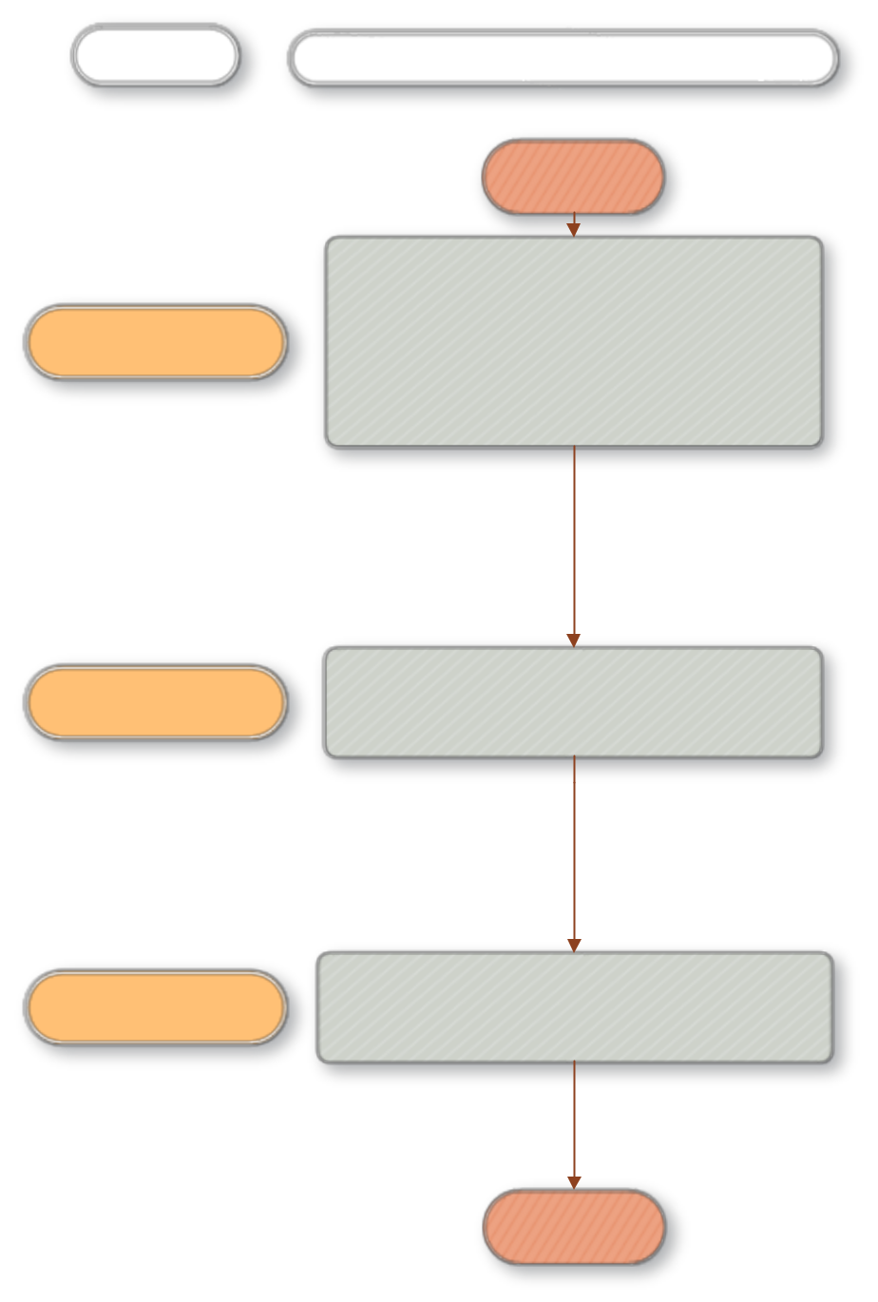
PEOPLE IN CHARGE

BAP Coordination

WORK FLOW

BEGINNING

Ensuring the distribution of projects according to 1 day

their respective Basic fields (Science and Mathematics, Architecture and Engineering Sciences, Social and Human Sciences, Agriculture and Food Sciences, Health Sciences, Sports Sciences, Fine Arts, Educational Sciences,) via BAP Automation to the Chairmen and Members of the Core Field Commission

Core Commission Members | Sending the projects by the Core Field Commissioners to the External Consultants.for evaluation |   30 days

Core Commission Members | Receiving the project suggestion evaluation from the core field commissioners
Core Commission Members | .

END

