
Nigde Omer Halisdemir University
Bilimsel Araştırma Projeleri
Koordinasyon Birimi
Proje Kabul ve Uygulama Birimi

JOB DESCRIPTION |  | CODE

Acceptance and implementation process of TÜBİTAK, KOP, SANTEZ, TAGEM
and Other projects.


PEOPLE IN CHARGE WORK FLOW
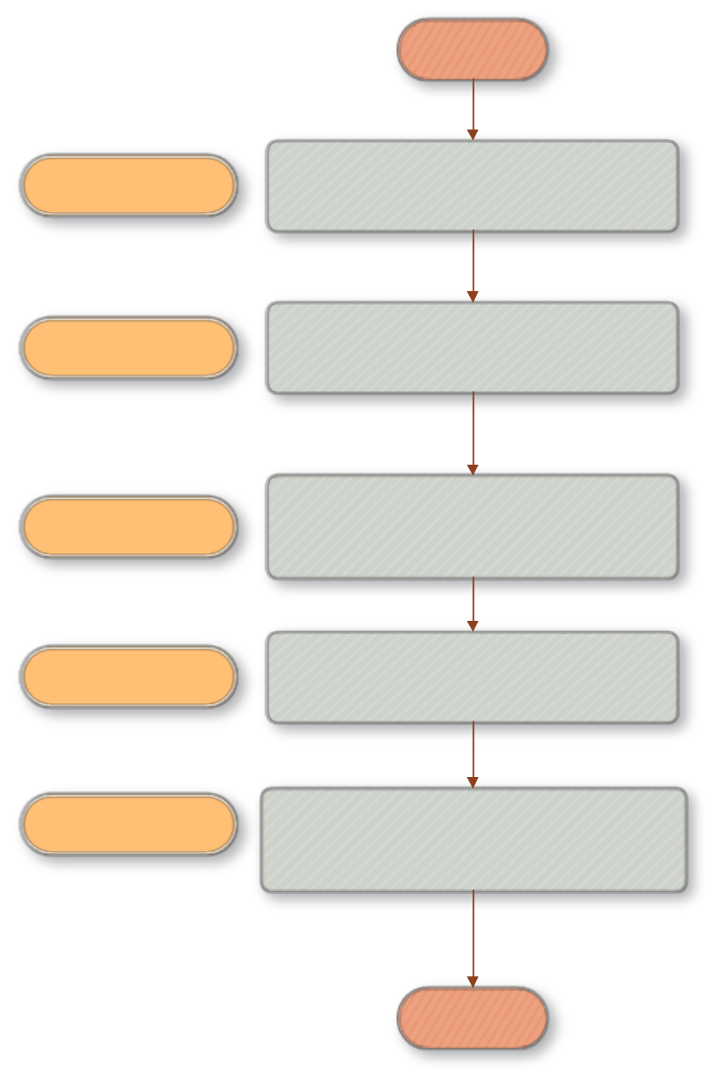

BEGINNING

TOTAL TIME
3 days 40 mins.

Project manager

Civil servant

Civil servant

Project manager, civil servant

Civil servant, BAP coordinator

Delivery of the accepted project contract by the relevant institution
and the project itself by the executive
to our unit

Opening a file for the accepted project

Making the necessary correspondence for the accepted project (expenditure officer, realization officer, etc.) and notifying the Strategy Development Department

Arranging the expenses by examining the requests from the project coordinator of the accepted projects

Closing the project and processing it to the required places based on the letter to close the project account of the expired project from the Strategy Development Department

10 mins.



- day


- days


30 mins.

END

