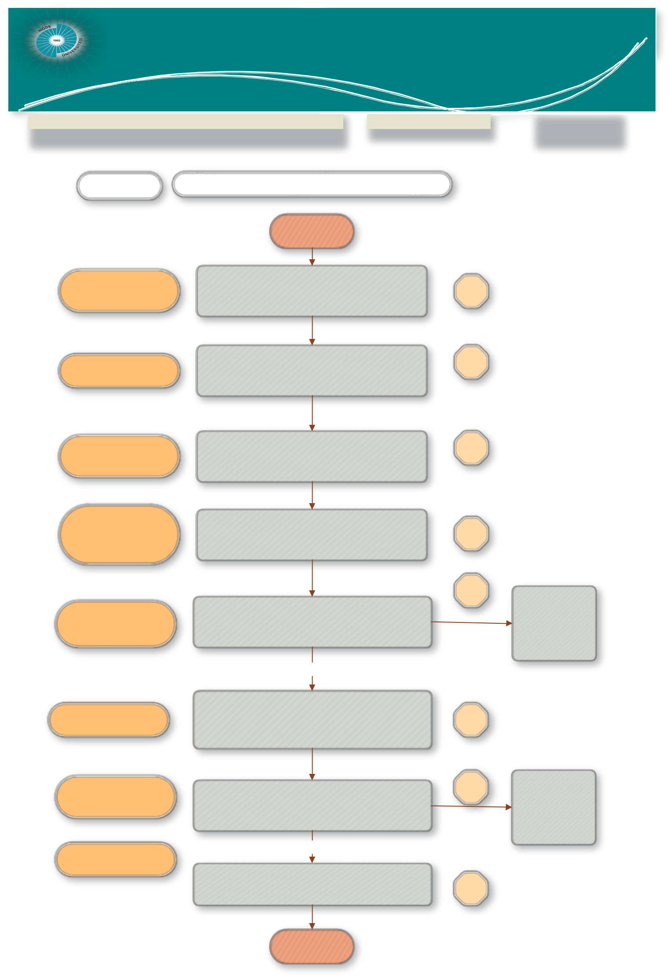
Scientific research projects

Nigde Omer Halisdemir University Coordination unit
Project Acceptance and Monitoring unit

JOB DESCRIPTION |  |  | CODE |  | TOTAL TIME
Project Acceptance and Monitoring Process |  |  |  |  | 11 days 5 hours
People in charge | WORK FLOWİ
 | BEGINNING

Civil servant, BAP Coordinator, BAP Commission President and Members

Civil servant

Project Manager, BAP Coordinator, Head of BAP Committee

Project Manager, civil servant,
BAP Coordinator, BAP Commission President and Members

Civil servant, BAP Coordinator, BAP Commission President and Members, Project Coordinator

Discussing the Project Evaluation Forms from the Core Field Commission in the BAP Commission and notifying the Project Managers.

Preparation of the Project Support Protocol by BAP Unit

Making support protocol with project executives

.

Sending the 1st progress report from the progress reports every 6 months to the reporter determined by the BAP Commission.

Receiving Progress Reports from the reporter and notifying the project executives. (Acceptance / revision or rejection of interim report)

Acceptance

1
week

2
hours

1
hour

1 day

- day

Sending project interim report to the project principle investigator
Revise/reject

Project managers, civil servant

Civil servant, BAP Coordinator, BAP Commission Members.Project Manager

Project manager, civil servant
Receiving the final report from the Project Executives after the end of the project period and sending the Project result reports to the predetermined reporter for evaluation.

The project is terminated by discussing the final report from the reporter at the BAP Committee.

Acceptance

The completed project is notified to the project manager

- day

2 |  | Sending project final report to the principle investigator
hours |  | Sending project final report to the principle investigator
Revise/rejection

END

