Nigde Omer Halisdemir University | Scientific Research Projects
Nigde Omer Halisdemir University | Coordination Unit
 | Project acceptance and implementation unit


JOB DESCRIPTION |  | CODE |  | TOTAL TIME
Project Application Process |  |  |  | 10 days
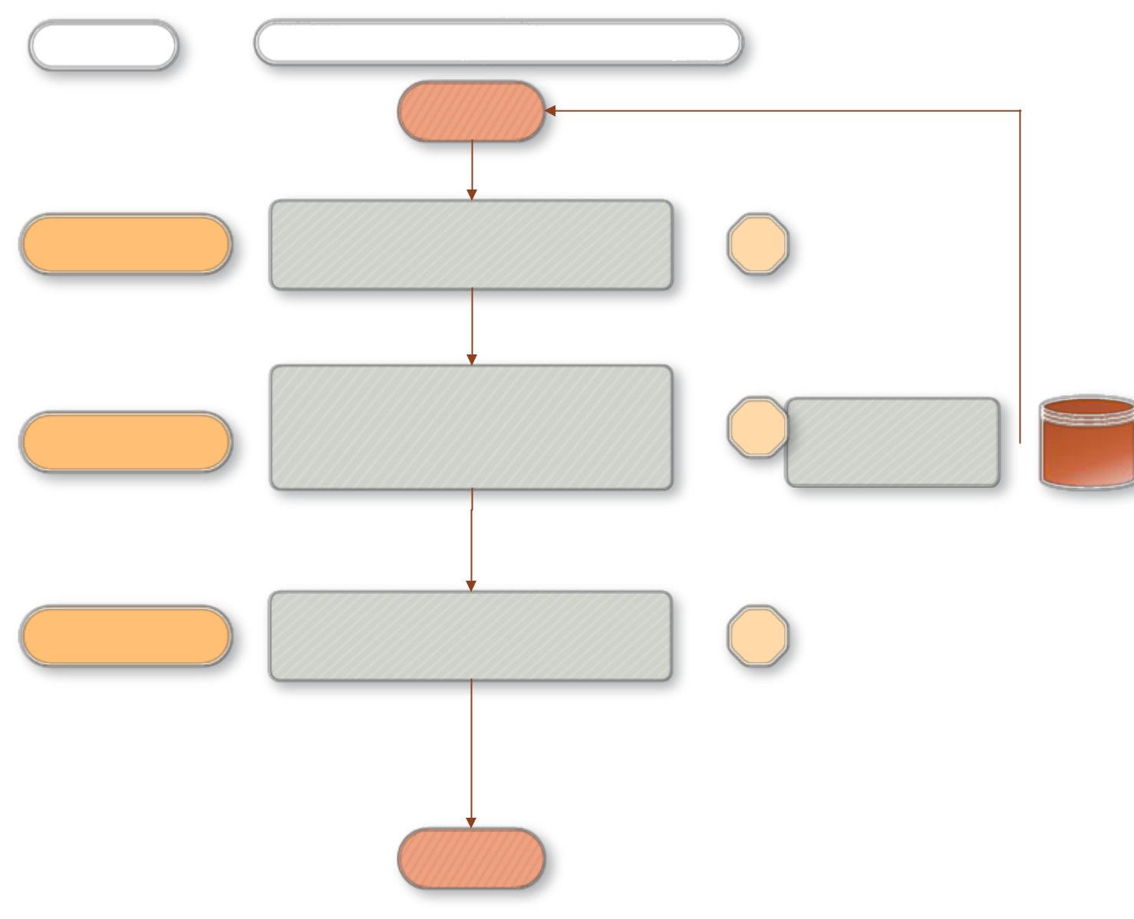

People in charge WORK FLOW

BEGINNING

Civil servant | Receiving applications through the BAP Automation system during project application periods | 7days

 | The control of the projects made through the BAP Automation system | 2 days
BAP Coordination | (the examination of whether or not projects are | Projects are reordered
 | in compliance with the directive and BAP criteria
 |  |  |  | BAP
 |  |  |  | Automation

Civil servant | Receiving the documents of projects that meet the application criteria by hand. | 1 day

END

