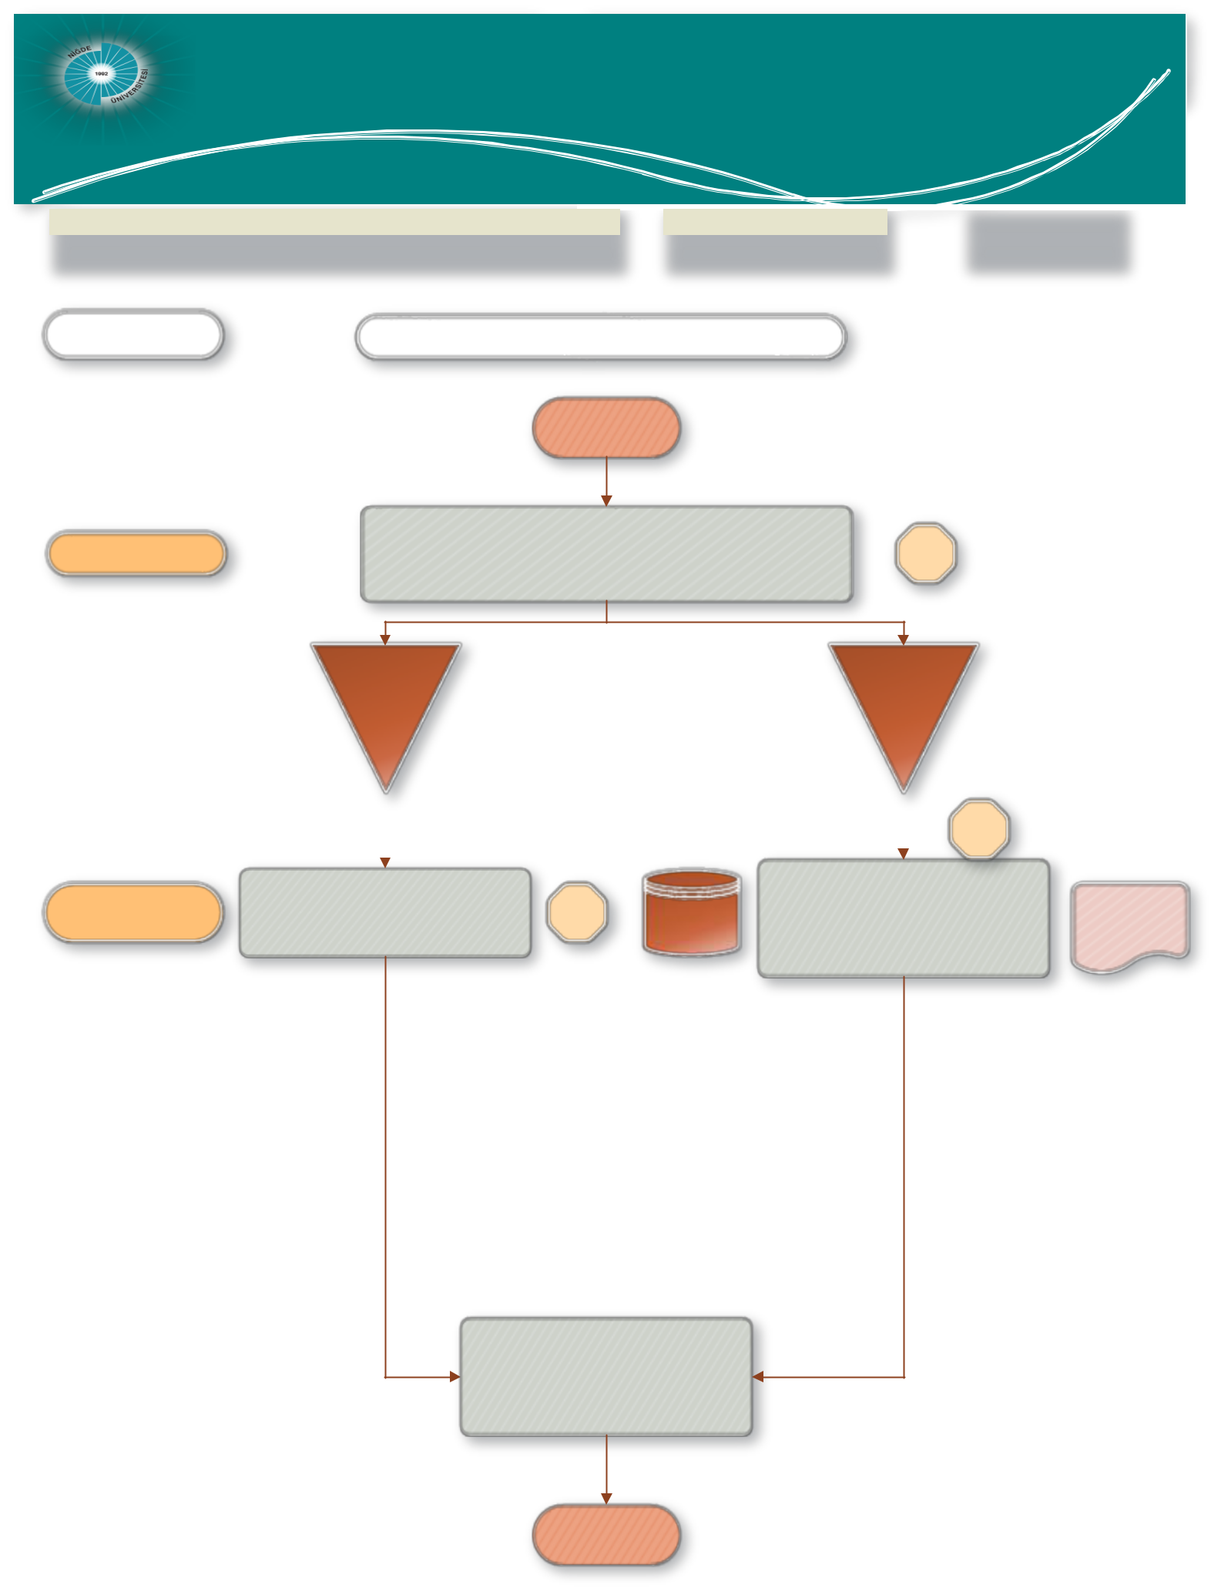
Scientific research projects
Nigde Omer Halisdemir University Coordination unit
Editorial Department

JOB DESCRIPTION |  |  | CODE |  | TOTAL TIME
Outgoing Document Process |  |  |  |  | 17 mins.
PEOPLE in CHARGE | WORK FLOW
 | BEGINNING

Civil servant Opening the edited document in the system. 2 mins.

Within institution Out-of-the institution

 |  |  |  |  |  | 15
 |  |  |  |  |  | dk.
 | Submitting the document attachments to document department to be sent to the faculty in question |  |  |  | Submitting the document to the outgoing document section by hand in order to complete its cargo and postal service processes. |  | Document to be submitted to postal service
Civil servant |  |  | 2 mins. | EBYS |  |  | Document to be submitted to postal service

Filing the completed document

END

