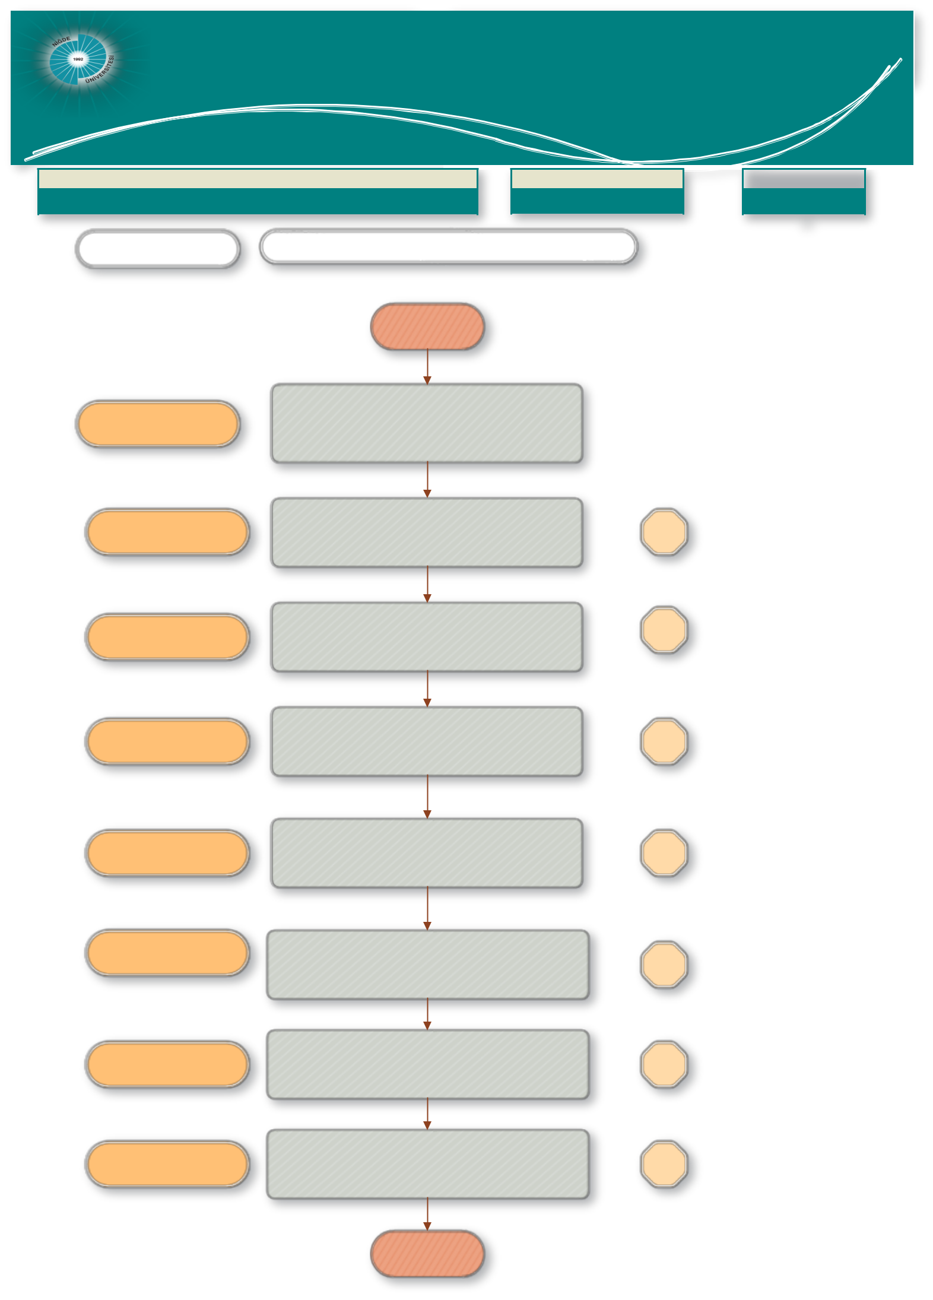
Bilimsel Araştırma Projeleri
Nigde Omer Halisdemir Universityoordinasyon Birimi Proje Kabul ve Uygulama Birimi

JOB DESCRIPTION | CODE | TOTAL TIME

BAP Commission Meeting Process |  |  |  |  | 10 days 5 hours 15
 |  |  |  |  | dk
PEOPLE in CHARGE | WORK FLOW

BEGINNING

Project manager

Civil servant,

Civil servant,

Civil servant, BAP Coordinator

BAP Coordinator

Civil servant, BAP Coordinator,
BAP Commission head and members

Civil servant, BAP Coordinator

Civil servant, BAP Coordinator, BAP Commission Members

Getting requests regarding transfer between budget subsections, additional time, additional appropriation, new project proposals and others regarding ongoing projects from the Project Managers

Control of claims and preparation of Agenda Items to discuss demands at the BAP Commission meeting.

To set a date for the BAP Commission meeting and to call the Chairman and Members of the Committee to the meeting..

Signing the Agenda Items on the EBYS system and notifying the BAP Commission President and Members.

Making preparations for the BAP Commission Meeting.

Holding the BAP Commission Meeting.

Writing down the decisions made at the meeting.

Preparing the official letters of the decisions, notifying the relevant Executive through the EBYS System and sending the attachments via documents.

- day

2
hours

15 mins,

- days

2
hours

- days

- days

END

