**Master’s Degree Programs**

[**ARTICLE 35**](https://static.ohu.edu.tr/uniweb/media/portallar/fenbilimlerienstitusu/sayfalar/3702/0scp0bdn.pdf) **Duration**: The normal duration of a master’s program with a thesis is four semesters, excluding the period spent in the Academic Deficiency Program, starting from the terms when the courses of the relevant program are completed, and the maximum duration of the program is six semesters.

[ARTICLE 23](https://static.ohu.edu.tr/uniweb/media/portallar/fenbilimlerienstitusu/sayfalar/3702/0scp0bdn.pdf) : Specific subjects and specialized field courses

*Specific subject courses are valid from the date when the thesis subject of the student who has registered to the master’s programs with thesis and has been assigned with an advisor, has been offered together with thesis proposal form until the end of second semester at the latest, and has been approved by EYK***.***

The information regarding the courses that the student needs to choose is provided below.

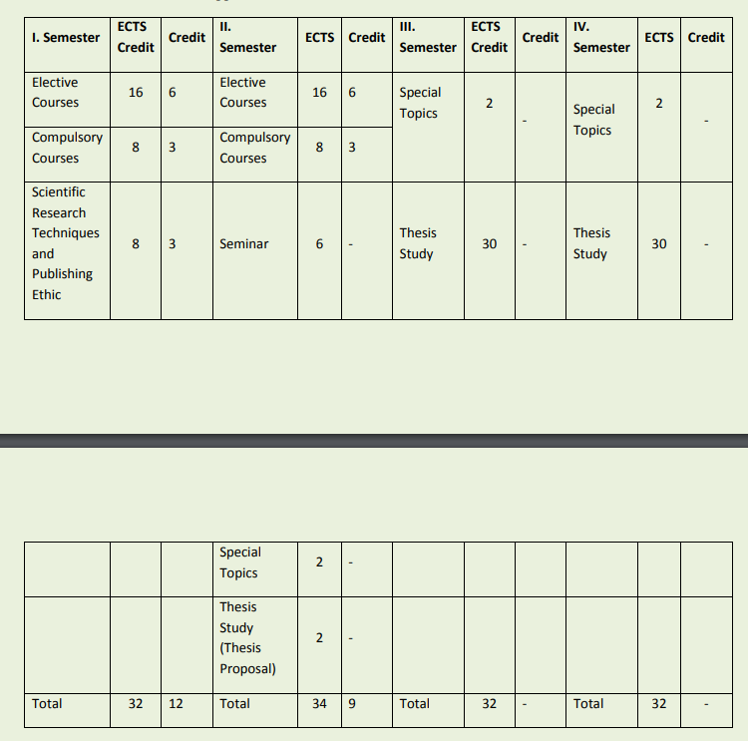

Students who fail to pass the thesis proposal in the 2nd semester will also choose “Special Topics” and “Thesis Study (thesis proposal)” in the 3rd semester.

*3. Students who register for “Special Topics and Thesis Study” in the 3rd and 4th semesters and are deemed successful can take the defence exam at the end of the semester. ***(***Semester: During the course stage, it refers to the period of study lasting at least fourteen working weeks except exam days, including fall and spring semesters, the start and end of which is determined by the Senate each academic year as for the thesis or term project stage it refers the period from the beginning of a semester to the beginning of the next semester***)***

For detailed information, please refer to the GRADUATION REQUIREMENTS!

**For the Thesis Proposal**: “Thesis Topic Proposal Form” is prepared by the student and the advisor faculty member. The relevant documents are submitted to the Department Secretary. “Thesis Topic Proposal Form” should be entered into OGRIS in PDF or Word format. After the necessary approvals (Advisor-Department Chair) are completed, it is sent to our Institute for discussion at the Department Council and EYK. If the “Thesis Topic Proposal Form” is accepted, the OGRIS approval will be completed by the Institute Student Affairs.

Students whose Thesis Topic Proposals are approved by the Institute Board of Directors must promptly fill out the "Thesis Upper Data Entry Form" available at <https://tez.yok.gov.tr/UlusalTezMerkezi/giris.jsp>.

**Documents to be Submitted to the Institute through the Electronic Document Management System (EBYS) via the Department:**

-Advisor Petition

- Department Board Decision