**PhD Program:**

[**ARTICLE 46**](https://static.ohu.edu.tr/uniweb/media/portallar/fenbilimlerienstitusu/sayfalar/3702/0scp0bdn.pdf)**: Duration (**2) Successful completion of the credited courses required for the Ph.D. program is four semesters for those who are admitted with a maximum graduation degree and six semesters for those who are admitted with a bachelor’s degree. In this period, the student who cannot successfully complete the courses with credits will be dismissed from the University.

(3) The student who successfully completes his/her courses who is successful in the proficiency exam and whose thesis proposal is accepted but cannot complete the thesis study until the end of twelve or fourteen semesters mentioned in the first paragraph is dismissed from the University.

(6) For the student to present his/her thesis, he/she has to register the thesis study and specialized field courses and be successful, from the semester following the semester in which the thesis proposal is accepted by EYK.

[**ARTICLE 50: 1)**](https://static.ohu.edu.tr/uniweb/media/portallar/fenbilimlerienstitusu/sayfalar/3702/0scp0bdn.pdf) **F**or the student who is successful in the proficiency examination, with the advisor’s proposal and the decision of the board of the department /art major and the decision of the EYK, a TİK is composed within a month.

**Documents to be Submitted to the Institute through the Electronic Document Management System (EBYS) via the Department:**

* Doctoral Thesis Committee Proposal Form
* Advisor Petition
* Department Council Decision

* Specialized field course is valid from the date when the thesis proposal of the student in doctorate program and qualifying programs in arts is approved by EYK. Doctoral student must register to specialized field course in the semesters after the semester when s/he has been successful in the proficiency exam.

* Students who will propose a thesis proposal within the semester they are registered in must be recommended to the institute by the department council before the Next Academic Registration Date specified in the academic calendar. If the student’s Thesis Proposal is accepted by the institute board (EYK), the student is considered to be successful in the Thesis Study (Thesis Proposal) and must register for the thesis study from the semester following the success of the student.

[ARTICLE 51: 1)](https://static.ohu.edu.tr/uniweb/media/portallar/fenbilimlerienstitusu/sayfalar/3702/0scp0bdn.pdf) The student who successfully completes the PhD proficiency exam and registers the thesis proposal, orally defends the thesis proposal which includes the purpose, method and work plan of the research that will be done within six months at the latest. The student submits a written report on the thesis proposal to the members of the TIK at least fifteen days before verbal defence.

* Students who fail to pass the thesis proposal during the semester will have to choose both “specialization field course” and “Thesis Proposal” in the following semester as well.

*4) For the student whose thesis proposal has been approved, the TAC convenes at least twice a year, once between January and June and once between July and December.

**Documents to be Submitted to the Institute through the Electronic Document Management System (EBYS) via the Department:**

Advisor Petition

Interim Report on Thesis Work Submission with CD

[Evaluation Form of Interim Report on Thesis Work](https://static.ohu.edu.tr/uniweb/media/portallar/fenbilimlerienstitusu/sayfalar/3134/dj3ynjp1.doc)

The information regarding the courses that the student needs to choose is provided below.

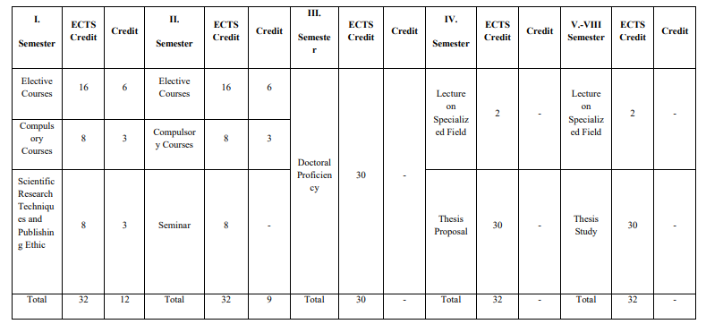

* For the finalization of a student’s thesis, he/she must register for the thesis study for four semesters and be successful and at least three Thesis Monitoring must be submitted after the thesis proposal is accepted.

**For the Thesis Proposal** “Thesis Topic Proposal Form” is prepared by the student and the advisor faculty member. The relevant documents are submitted to the Department Secretary. “Thesis Topic Proposal Form” should be entered into OGRIS in PDF or Word format. After the necessary approvals (Advisor-Department Chair) are completed, it is sent to our Institute for discussion at the Department Council and EYK. If the “Thesis Topic Proposal Form” is accepted, the OGRIS approval will be completed by the Institute Student Affairs.

Students whose Thesis Topic Proposals are approved by the Institute Board of Directors must promptly fill out the “Thesis Upper Data Entry Form” available at <https://tez.yok.gov.tr/UlusalTezMerkezi/giris.jsp>.

**Documents to be Submitted to the Institute through the Electronic Document Management System (EBYS) via the Department.**

- [Record Form of Thesis Proposal Defence Exam](https://static.ohu.edu.tr/uniweb/media/portallar/fenbilimlerienstitusu/sayfalar/3134/a1mohrdp.doc)

- Advisor Petition

[For detailed information, please refer to the GRADUATION REQUIREMENTS!](https://ohu.edu.tr/fenbilimlerienstitusu/sayfa/mezun-olma-sartlari)