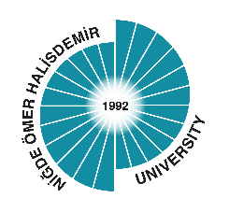 | REPUBLIC OF TURKEY  NIGDE OMER HALISDEMIR UNIVERSITY  NIGDE VOCATIONAL SCHOOL OF SOCIAL SCIENCES  DEPARTMENT OF …....…………………..  Internship Evaluation Form

Name, Surname |  |  |  | PHOTOGRAPH
Department
Student ID Number
Program | Daytime Evening
Institution Name
Internship Start Date
Internship End Date
Number of Working Days
Number of days not worked
Internship Cycle | 1st cycle 2nd cycle
 | CONSIDERATIONS |  | Grade
Attendance
Determination to work
Attitude towards the manager
Attitude towards the co-workers
Grades: A(Excellent) B(Good) C(Fair) D(Below Average) E(Insufficient)
APPROVAL
The name, surname, signature and seal of the workplace's manager who controls the work |  | Result and Approval  (This part will be filled in by the departmental internship commission.)
NOTE: The Internship Evaluation Form will be filled in 2 (two) copies after the internship of the student is over. The second copy will be delivered to the trainee in a sealed envelope to be given to the Departmental Internship Commission.

