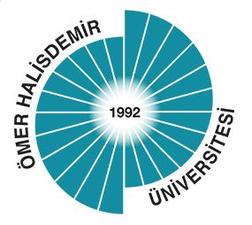

**ÖMER HALİSDEMİR UNIVERSITY FACULTY OF MEDICINE**

**FIRST YEAR PHASE-VI**

**AIM:**

At the end of this phase, first year students will be able to list the properties of medical skills education and perform surgical handwashing, wearing sterile gloves, measuring blood pressure, intramuscular, subcutaneous, intravenous drug applications, closure and care of the wound and nasogastric catheterization at proficient level.

**INTENDED LEARNING OUTCOMES:**

At the end of this phase, first year students will be able to:

1. Describe competence in medical skill training,

2. Describe proficiency in medical skill training,

3. List the tools used in medical skill training,

4. Adopt to the importance of humanistic medical skills training,

5. Decide on what basic medical skills should be applied in clinical situations,

6. Perform hand washing before surgical intervention,

7. List and use the materials necessary to work in sterile conditions during the surgical intervention,

8. Wear sterile gloves,

9. Perform drug preparation for intramuscular, subcutaneous, intravenous injection,

10. Perform intramuscular injection,

11. Perform subcutaneous injection,

12. Perform intravenous injection,

13. List and explain the basic principles of intravenous fluid delivery,

14. Measure arterial blood pressure,

15. Know and use basic surgical instruments and consumables,

16. List the basic wound closure techniques and perform them,

17. Perform wound care,

18. Apply a nasogastric probe.