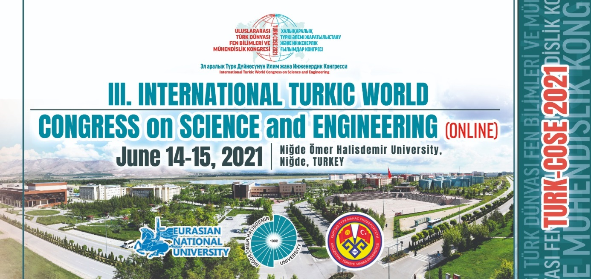
http://www.ohu.edu.tr/turk-cose-tr
http://www.ohu.edu.tr/turk-cose-kz
http://www.ohu.edu.tr/turk-cose-kg
http://www.ohu.edu.tr/turk-cose-en

3rd INTERNATIONAL TURKIC WORLD CONGRESS on SCIENCE and ENGINEERING

Abstract Format

Title of the Paper:
Author (s) of the Paper:
Institution and / or Title of the Author (s) :
E-mail Address of the Responsible Author:

Absract: up to 250 words
Keywords: up to 5 words
Special Thematic Session Proposal (Optional): To determine the session title which the abstract may be included, session chairman and theme

NOTES:
-Abstracts are accepted in Turkish and English, Kazakh and English or Russian and English.
-The abstract should be written in “Arial” font with 12 font size, max. 250 words, 1 point line spacing, to be aligned to both sides, in either doc. or docx. format, as a single file.
- Each participant can submit a maximum of 2 papers.

