TURK-COSE 2021

Author Name:
Author's Institutional Information:
Author's E-mail Address:

Abstract: It should include general information about the study subject, purpose, method, findings and conclusion sections, or those who want to write in short format should be written as purpose + method, findings and results.
Keywords: A, B, C, D, E..

Total Number of Words (max 3000)
Only the first letter of the titles will be capitalized. Titles and subtitles can be used as necessary as required. References will be given in the text as (Author, Date) Example: (Fox, 2014). The main text should be prepared as a single file, with 1 point line spacing, in "Arial" font, 12 font size, justified on both sides, and in .doc or .docx format.
1. Introduction
In the introduction section, basic information, literature information (knowledge of previous studies), scientific gap (requirement) and purpose should be written.
2. Materials and Methods
The information and details of the materials and methods used in this section should be fluent and inclusive.
What the materials cover: Laboratory equipment, Field equipment, Human and Animal subjects Natural Materials Industrial Materials, Boards, Tests, Computer Modules, Mathematical Models
What the Methods covers: Space / sample Space, Location, restrictions / limiting conditions, Operations, etc.
3. Findings
Findings section is presented with the obtained findings, graphs or tables, important findings are expressed, a possible explanation, comparison or generalization with other studies can be made.
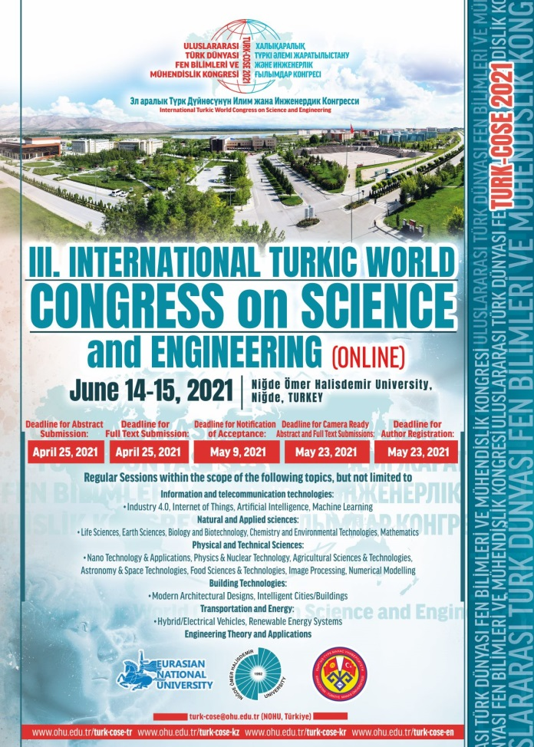
Figure 1. Template TURK-COSE 2021 poster as a figure (title and table should be centered)

Table 1 Template table (title and table should be centered)
Title 1 | Title 2 | Title 3

4. Results
In the results section, the original purpose is stated, the most important findings are given, comments, comparisons and generalizations are made regarding the findings, the limitations related to the work are stated and concluded with a statement
Acknowledgement
If there is an institution, organization or person to be thanked in this study, they are thankful.

References
All references in the text should be placed at the end of the text in alphabetical order according to the surname of the authors in accordance with the following reference notation.
Reference Display Examples (Harvard Style):
Book
- Daniels, K., Patterson, G. and Dunston, Y. (2014). The ultimate student teaching guide. 2nd ed. Los Angeles: SAGE Publications, pp. 145-151.
Periodical publication
- Dismuke, C. and Egede, L. (2015). The Impact of Cognitive, Social and Physical Limitations on Income in Community Dwelling Adults With Chronic Medical and Mental Disorders. Global Journal of Health Science, 7 (5), pp. 183-195.
Conference Proceedings
- Palmer, L., Gover, E. and Doublet, K. (2013). Advocating for Your Tech Program. In: National Conference for Technology Teachers. [online] New York: NCTT, pp. 33-34. Available at:
http://www.nctt.com/2013conference/advocatingforyourtechprogram/
(Accessed 11 Jan. 2014).
- Fox, R. (2014). Technological Advances in Banking. In: American Finance Association Northeast Regional Conference. Hartford: AFA, p. 24.
Online Resources
- World Urbanization Prospects (2008). The 2011 Revision Population Database. (http://esa.un.org/unup/ ) Accessed 12 Dec. 2018.

