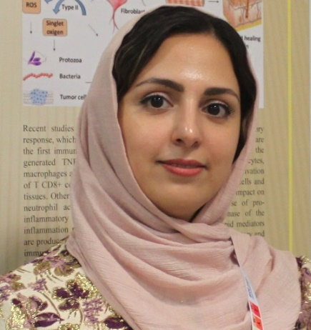
Dr. Khatereh Khorsandi (Ph.D in Biochemistry) is working as faculty member (Assistant Professor) and head of Photodynamic Department at Medical Laser Research Center, YARA Institute, ACECR, Tehran University of medical sciences (TUMS) branch, Tehran, IRAN. She is postdoctoral scientist at George Washington University, Washington DC, USA now. Her research interests include Photodynamic Therapy, Photobiomodulation, Photodynamic inactivation, cancer treatment and wound healing. She is the recipient of FAOBMB, IUBMB, ESP and IUPAB young scientist fellowship awards of 2016, 2018, 2019 and 2020-2021 years, respectively. She has published more than 50 research and review articles on the recognized international peer review journal and has invited as keynote speaker in international congresses in the field of cancer biology and wound healing particularly photodynamic therapy.

