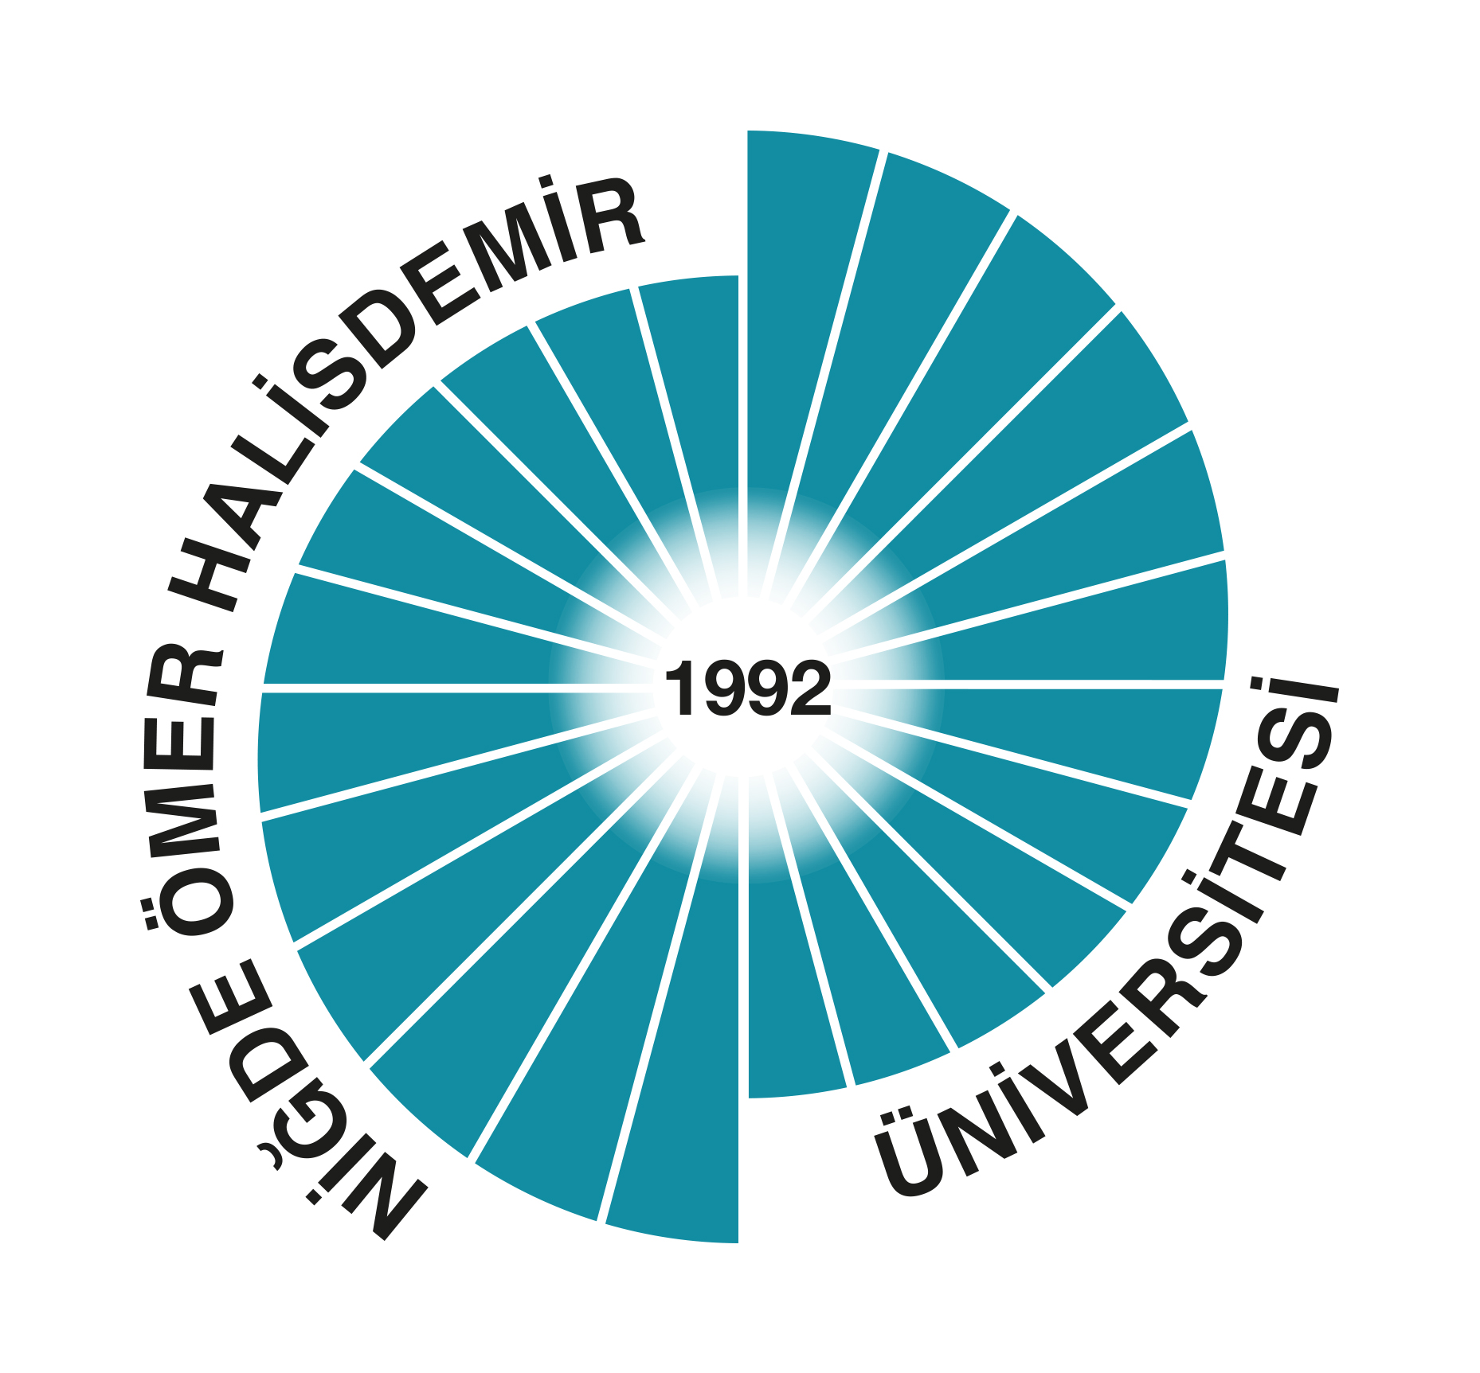 ERASMUS+ UNIKOP MOBILITY
NIGDE OMER HALISDEMIR UNIVERSITY
INTERNATIONAL RELATIONS OFFICE

Application Form for Academic Staff Mobility (UNIKOP)
(Please type or print in black ink (no handwriting, please)
I - PERSONAL INFORMATION
National ID No
Surname
Name (First / Middle)
Title
Sex |  | Female Male
Date of Birth (Month/Day/Year) |  | / /
Place of Birth
Citizenship(s)
Faculty / Department/Unit |  | / /
Contact Details
Postal / Home Address
Telephone (Home / Mobile/Office) |  | / /
E-mail(s) |  | @
II. Explain briefly why you would like to go abroad under the scope of Erasmus programme, and how this would contribute to your academic and work career objectives:
III. Have you ever been abroad under the scope of Erasmus programmes? If yes, When?
IV. Could you please write what your work plan will be like when you are abroad?
V. INFORMATION ON YOUR Exchange PERIOD ABROAD
Which university / department do you plan to visit?
1 | Name of Department
1 | Name, postal address, e-mail and telephone of International / Erasmus Coordinator at host university
1 | Name of University
1 | Country
2 | Name of Department
2 | Name, postal address, e-mail and telephone of International / Erasmus Coordinator at host university
2 | Name of University
2 | Country
3 | Name of Department
3 | Name, postal address, e-mail and telephone of International / Erasmus Coordinator at host university
3 | Name of University
3 | Country
VI. Name and Signature of the Departmental Coordinator in your institution :

_________________________________________

VII. Please indicate your language competence
English French German Other

If you have a certificate of foreign language , please indicate:

KPDS UDS YDS IELTS TOEFL OTHER

What is your average point? : __________

VIII. Please tick the boxes by answering the following questions:
Yes No
- Have you ever made a bilateral agreement for Erasmus Mobility programme?
- Have you ever thought any courses to incoming students?
- Have you ever provided any incoming students coming to our university?
- Have you ever made a contact for developing our agreements?
- Have you ever given any courses in English language before?
IX. I, hereby confirm that all information in my application is completed and
correct.

Name of the Applicant :

Signature : ______________ Date : / /
Place :

Please hand in the completed application form to INTERNATIONAL rELATIONS oFFICE TOGETHER WITH THE LANGUAGE EXAM RESULT!

NOTE: The application of Erasmus+ Mobility programme for academic staff starts on 02.10.2017 finishes on 20.10.2017

