NİĞDE ÖMER HALİSDEMİR UNIVERSITY

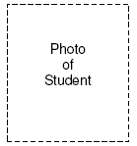
MOU PROTOCOL EXCHANGE PROGRAMME

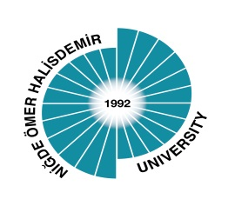

STUDENT APPLICATION FORM

ACADEMIC YEAR 202../ 202..

SENDING INSTUTITION:

Name and full address of the institution:
Name of the Academic Coordinator:  Name of Institutional Coordinator: | Phone: :  Email:

STUDENT’S PERSONAL DATA:
Family Name: | First Name(s):
Passport or ID number: | Sex: | Nationality:
Place of birth: | Date of birth
Mother’s Name: | Father’s Name:
Current address:

E-mail:

Current telephone:

Accommodation ; Yes : ☐ No: ☐
Language knowledge: Turkish : ☐ English : ☐
Level of Language knowledge:

HOST INSTITUTION:
Name and full address : Nigde Omer Halisdemir University, International Relations Office ,
Merkez Yerleske, Bor Yolu Uzeri, 51240 Nigde/ TURKEY

Name of the Institutional Coordinator : Hulya URUNDU, Lect. | Phone : +90388 225 2148  Email: international@ohu.edu.tr

DETAILS OF THE PROPOSED STUDY PROGRAMME AT HOME UNIVERSITY:

Field of study at home institution:

Field of study at HOST University (Faculty/Department):

Semester: Fall Spring Academic year
Duration of the stay in months:
Arrival date: | Departure date:

DECLARATION:
Signature of the Student : Date :

The statements made in this application form are correct and complete.

HOME UNIVERSITY:
Name of the Academic Advisor:  Signature:  Date :  Stamp: | Name of the International Relations Institutional Coordinator:  Signature:  Date :  Stamp:

HOST UNIVERSITY:
Name of the Academic Advisor:  Signature:  Date :  Stamp: | Name of the International Relations Institutional Coordinator:  Signature:  Date :  Stamp:

