
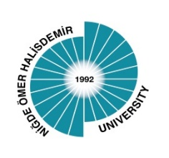
THE ACADEMIC COOPERATION PROTOCOL-MOUs

1 | AZERBAIJAN   | - Baku Eurasian University  - Azerbaijan State Economic University  - Khazar University  - Azerbaijan Academy of Labor and Social Relations  - Azerbaijan Medical University  - Azerbaijan Technical Unıversity  - Azerbaijan State Oil and Industry University
2 | BANGLADESH  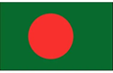 | - Noakhali Science and Technology University
3 | BULGARİA   | - The Agricultural Universıty-Plovdiv,Bulgaria
4 | BOSNİA AND HERZEGOVİNA   | - Tuzla University
5 | ECUADOR   | - Universidad Técnica Estatal De Quevedo
6 | IRAN  | - Amirkabir University of Technology  - Tabriz University  - Azerbaijan Shahid Madani University
7 | ITALY   | - "CIHEAM Bari" Enstitüte  - University of Politecnico Di Torino
8 | KAZAKHSTAN   | - Kazakh State Women’s Teacher Training University  - T.K. Zhurgenov Kazakh National Academy of Arts  - Al Farabi Kazakh National University  - Abai Kazakh National Pedagogical University  - L. N. Gumilyov Eurasian National University  - Atyrau State University  - Zhansugurov (Zhetysu) Üniversitesi  - University of Peoples Friendship Named After Academician A. KUATBEKOV  - And Non- Commercial Joint Stock Company "Semey Medical Unıversıty"  - Khoja Akhmet Yassawi International Kazakh-Turkish University  - Karaganda Medical Universıty  - Caspian University of Technology and Engineering n.a. Sh. YESSENOV  - JSC, International Information Teghnology University  - Altynsarin Arkalyk Pedagogical Institute  - Shakarim University of Semey  - Asfendiyarov Kazakh National Medical University, Almaty  - Astana International University  - Kazakh National Agrarian Research University  - Turan University  - Abay Myrzakhmetov Kokshetau University  - Margulan University  - Tashanev University
9 | KOSOVO   | - University of Prishtina "Hasan Prishtina"  - UBT Higher Education Institution
10 | NORTH MACEDONIA   | - International Vision University  - International Balkan University
11 | KYRGYZSTAN TURKEY  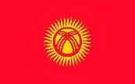 | - CAUA Exchange Programme Pilot Implementation Protocol (Kyrgyzstan-Turkey Manas University)
12 | KYRGYZSTAN | - OSH Stsate University  - Kyrgyz-Uzbek International University n.a. Batyraly Sydykov  - International Higher School of Medicine  - OSH Technological University
13 | MOLDOVA  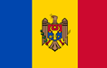 | - Comrat State University (Moldova)
14 | SOUTH KOREA   | - Sungshin University
15 | UZBEKISTAN 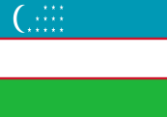 | - Tashkent State University of The Uzbek Language and Literature Named After ALISHER NAVA'I  - Bukhara State University  - National University of Uzbekistan Named After Mirzo Ulugbek  - Tashkent Satate Transport University  - Karshİ State Unıversity  - Turon University  - Oriental University
16 | PAKISTAN  | - University of Veterinary and Animal Sciences, Lahore  - National University of Science and Technology, Islamabad  - University of Punjab  - Bahauddin Zakariya University, (Centreof Excellence in Molecular Biology, Pakistan)  - Pir Mehr Ali Shah University of Arid Agriculture
17 | PERU   | - Universidad Nacional Agraria La Molina  - Universidad Nacional Jorge Basadre Grohmann
18 | PHILIPPINES   | - Philippines Üniversity
19 | POLAND   | - Cracow University Of Technology
20 | RUSSAN FEDERATON  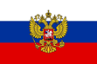 | - Bashkir State Pedagogical University n. a. M. Akmulla
21 | ROMANYA   | - National Institute of Research and Development For Potato and Sugar Beet
22 | SOMALIA   | - Horseed International University
23 | SUDAN   | - University of Al Butana  - Al Neelain University
24 | TUNUSIA   | - University of Sfax  - Institut Des Regions Arides Medeniner
25 | TURKISH WORLD | - International Turkic World Science and Engineering Sciences Congress  - Protocol on the Organisation of International Symposium on Turkic World Studies
26 | Turkish Republic of  Northern Cyprus  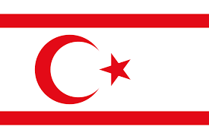 | - Near East University  - European University of Lefke  - Cyprus Science University  - Eastern Mediterranean University  - Girne American Üniversity  - Cyprus International University  - American University of Cyprus
27 | VIETNAM  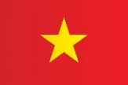 | - University of Agriculture and Forestry, (HUE University)
With 27 countries, 82 MOUs -Protocol Agreements have been signed so far.

